Bluetooth and Arduino

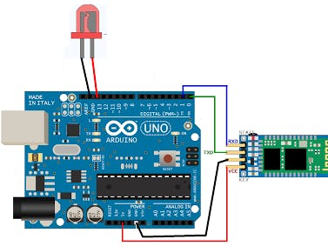

- #define ledPin 13
- int state = 0;
- void setup() {
- pinMode(ledPin, OUTPUT);
- digitalWrite(ledPin, LOW);
- Serial.begin(38400);
- }
- void loop() {
- if(Serial.available() > 0){
- state = Serial.read();
- }
- if (state == '0') {
- digitalWrite(ledPin, LOW);
- Serial.println("LED: OFF");
- state = 0;
- }
- else if (state == '1') {
- digitalWrite(ledPin, HIGH);
- Serial.println("LED: ON");;
- state = 0;
- }
- }

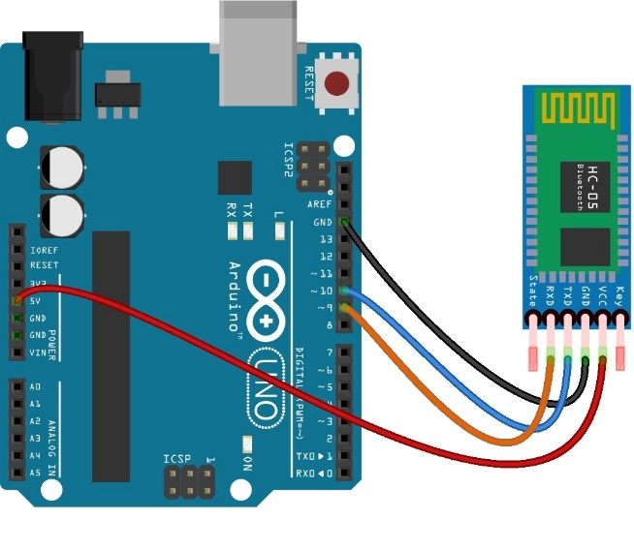

#include <SoftwareSerial.h>

#define rxPin 9
#define txPin 10

int ledPin = 13;
SoftwareSerial mySerial = SoftwareSerial(rxPin, txPin);

void setup()
{
// define pin modes for tx, rx, led pins:
pinMode(rxPin, INPUT);
pinMode(txPin, OUTPUT);
pinMode(ledPin, OUTPUT);

mySerial.begin(9600);
Serial.begin(9600);
}

void loop()
{
if (mySerial.available()>0)
{
char someChar = mySerial.read();
if ( someChar=='1')
{
digitalWrite(ledPin, HIGH);
}
if ( someChar=='2')
{
digitalWrite(ledPin, LOW);
}

mySerial.print(someChar);
Serial.print(someChar);
}

}

Motion Detection Sensors

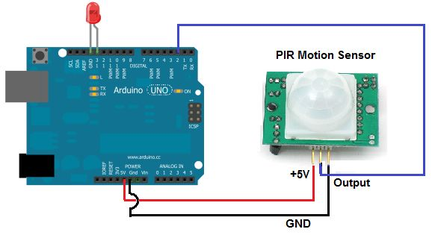
- int ledPin = 13; // choose the pin for the LED
- int inputPin = 2; // choose the input pin (for PIR sensor)
- int pirState = LOW; // we start, assuming no motion detected
- int val = 0; // variable for reading the pin status

- void setup() {
- pinMode(ledPin, OUTPUT); // declare LED as output
- pinMode(inputPin, INPUT); // declare sensor as input

- Serial.begin(9600);
- }

- void loop(){
- val = digitalRead(inputPin); // read input value
- if (val == HIGH) { // check if the input is HIGH
- digitalWrite(ledPin, HIGH); // turn LED ON
- if (pirState == LOW) {
- Serial.println("Motion detected!");
- pirState = HIGH;
- }
- } else {
- digitalWrite(ledPin, LOW); // turn LED OFF
- if (pirState == HIGH){
- Serial.println("Motion ended!");
- pirState = LOW;
- }
- }
- }

